Machine Learning Recap Notes

Introduction

What is Machine Learning?

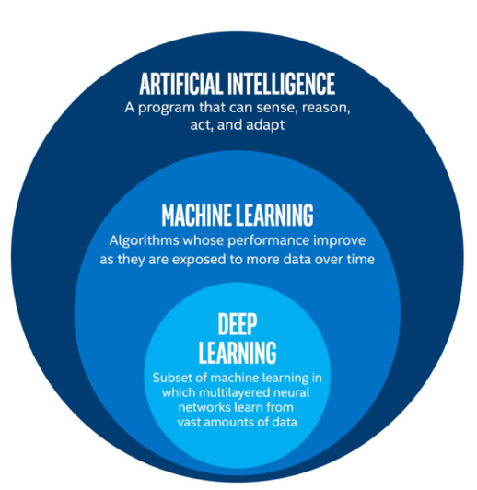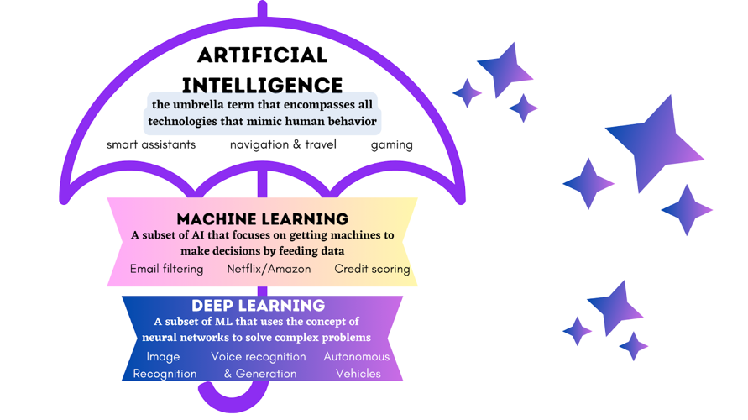

Machine Learning (ML) is a subset of Artificial Intelligence (AI) that enables computers to learn and make decisions from data without being explicitly programmed for every task.
So instead of writing specific instructions, we provide algorithms with examples and let them find patterns.
Think of ML like teaching a child to recognize animals. Instead of describing every detail of what makes a cat a cat, you show them hundreds of pictures of cats and dogs. Eventually, they learn to distinguish between them on their own.

Why is Machine Learning Important?

Automation: Automate complex decision-making processes

Pattern Recognition: Find hidden patterns in large datasets

Prediction: Make predictions about future events

Personalization: Customize experiences (like Netflix recommendations)

Efficiency: Process vast amounts of data quickly

Glossary

Features (X): Input variables (like height, weight, age)

Target/Label (y): What we want to predict (like price, category)

Data: The information we feed to our algorithms

Dataset: Collection of data

DataFrame: 2D table-like data structure in pandas

Training Set: Dataset used to teach the algorithm

Test Set: Dataset used to evaluate performance

Algorithm: The mathematical method used to find patterns

Model: The result after training an algorithm on data

Machine Learning Pipeline
Machine Learning Pipeline=

Step Short Definition

1. Data Ingestion Load data from files, APIs, or databases
2. Data Preprocessing Clean and fix messy data
3. Data Exploration Look at data to understand patterns
4. Feature Engineering Create better input variables
5. Model Selection Pick the best algorithm
6. Hyperparameter Tuning Adjust settings for better performance
7. Model Training and Evaluation Train model and test accuracy
8. Model Deployment Put model into real use

Data Ingestion
→ The process of gathering data from various sources:

CSV files
SQL databases APIs
Real-time streams

Data Preprocessing
→ Cleaning the raw data to make it usable, including:

Handling missing values Removing duplicates
Converting data types
Normalizing values
Fixing errors or inconsistencies

Data Exploration
→ Also known as Exploratory Data Analysis (EDA). We analyze data to understand patterns, correlations, and potential issues, using:
Charts Summaries Visualizations

Feature Engineering
→ Creating or modifying input variables (features) to help the model learn better. This step transforms raw data into more meaningful representations. For example:
Converting "date of birth" into "age" to make it a usable number Creating "BMI" from "height" and "weight"
Encoding categories (e.g., turning "Male" / "Female" into 0 and 1)

Model Selection
→ Choosing the appropriate algorithm based on the task (e.g., regression, classification, clustering). The choice depends on:
Data type
Project goal
Need for interpretability

Hyperparameter Tuning
→ Adjusting the model’s settings (like tree depth, number of clusters, or learning rate) to improve performance.
Good hyperparameters can greatly boost model accuracy and reduce
overfitting.

Common techniques include:

Grid Search: Tries all possible combinations of hyperparameter values Random Search: Tries random combinations for faster results on large
spaces
These methods help find the best settings based on validation performance (e.g., accuracy or RMSE)

Model Training and Evaluation
→ Training the model on a training dataset and then evaluating it on a test dataset. We measure how well it performs using metrics like:
Accuracy
Precision & Recall
RMSE (Root Mean Square Error = how far your predictions are from the real values), etc.

Model Deployment
→ Putting the trained model into real-world usage, such as:

Integrating into a web or mobile app Embedding into backend systems
Making real-time predictions on new, unseen data

Types of Machine Learning

Types of Machine Learning

Definition
Unsupervised Learning

Finding patterns in data without labeled examples

Supervised Learning
Learning with labeled examples (we know the correct answers)

Reinforcement Learning

Learning through trial and error with rewards/penalties

Examples
- Customer segmentation
- Market basket analysis
- Anomaly detection
- Email spam detection (spam/not spam)
- House price prediction
- Image recognition
- Game playing (chess, Go)
- Robot navigation
- Trading strategies

Common Algorithms
- K-Means Clustering
- Hierarchical Clustering
- Principal Component Analysis (PCA)
- Linear Regression
- Decision Trees
- Random Forest
- Support Vector Machines
  - Q-learning
  - Deep Q-Networks (DQN)
  - Policy Gradient Methods

Common Algorithms

Linear Regression
Linear Regression

Definition: A model that predicts a continuous value based on the relationship between input features and the target.
Use Case: Predicting prices, trends (e.g., house price prediction).

Strengths Weaknesses

Simple and easy to interpret Struggles with non-linear patterns
Works well when the relationship is linear Sensitive to outliers

Decision Trees
Decision Tree

Definition: A tree-based model that splits the data based on feature values to make decisions.
Use Case: Classification problems like determining whether an email is spam or not.

Strengths Weaknesses

Easy to understand and visualize Prone to overfitting
Can handle both numerical and categorical data
Small changes in data can lead to a completely different tree
No need for feature scaling

K-Means Clustering
K-Means Clustering

Definition: An unsupervised algorithm that groups data into K clusters based on similarity.
Use Case: Customer segmentation, grouping similar users or products.

Strengths Weaknesses

Fast and efficient for large datasets
Requires choosing K (number of clusters) manually

Easy to understand and implement
Doesn’t work well with non-spherical clusters or different cluster sizes
Sensitive to outliers

Additionals

Overfitting vs Underfitting
Underfitting vs Overfitting 1 Underfitting vs Overfitting 2

Underfitting (Too Simple)

What it is Model is too basic to
capture real patterns

Overfitting (Too Complex)
Model memorizes training data instead of learning general patterns

Good Fit (Just Right)

Model captures the true underlying patterns

Example
Using a straight line to A student who predict house prices memorizes answers when the relationship but can't solve new is curved problems
A student who understands the concepts and can apply them in new situations

Signs
Poor performance on both training and test data
Great performance on training data, terrible on new data
Good performance on both training and test data

Symptoms
High bias, low variance
Low bias, high variance
Balanced bias and variance

Solution
Underfitting (Too Simple)

Use more complex models or add more features

Overfitting (Too Complex)

Use simpler models, get more data, or apply regularization

Good Fit (Just Right)
Maintain a good balance between model complexity and data quality

How to Detect:
# Training accuracy: 95%
# Test accuracy: 96% ← Good fit!

# Training accuracy: 60%
# Test accuracy: 58% ← Underfitting

# Training accuracy: 99%
# Test accuracy: 65% ← Overfitting

Bias-Variance Tradeoff
Bias Variance Tradeoff

Bias: Error due to overly simple assumptions (underfitting)

Variance: Error due to too much complexity (overfitting)

Goal: Find a balance where both are low

High Bias → Model is too simple → Underfitting High Variance → Model is too complex → Overfitting
Just Right → Low bias and low variance → Good generalization

Tips to Increase Model Accuracy

Clean your data properly

Feature engineering (create meaningful input variables)

Try different models and compare

Use cross-validation

Tune hyperparameters (e.g., learning rate, depth, number of trees)

Add more high-quality data

Use ensemble methods (e.g., Random Forest, XGBoost)

Regularize your models (e.g., L1/L2 regularization)

Useful References

Online Resources

FreeCodeCamp

Website: freecodecamp.org YouTube Channel: FreeCodeCamp Popular Videos:
Intro to Machine Learning

Machine Learning Crash Course

DataCamp

Website: datacamp.com

Dataset

Kaggle: kaggle.com/datasets (huge collection of real datasets)

UCI ML Repository: archive.ics.uci.edu/ml (classic ML datasets)

Google Dataset Search: datasetsearch.research.google.com

Government Data: data.gov (US), data.gov.sg (Singapore)

Awesome Public Datasets: github.com/awesomedata/awesome-public- datasets

🎯 Let's Code: YouTube Trending Video Analysis
In this notebook, we’ll walk through a complete mini data science project using
real-world YouTube trending data.

What We’ll Cover:
- Data Ingestion – Load trending video data from CSV and SQL database
- Data Preprocessing – Remove invalid, zero, or error-filled entries
- Data Exploration – Visualize distributions and trends in views, dates, and features

- Feature Engineering – Create new variables like ratios, title length, and publish timing
- Model Selection – Compare classification models (Random Forest, Gradient Boosting, AdaBoost)
- Hyperparameter Tuning – Use GridSearchCV to find the best model settings
- Model Training & Evaluation – Train models and evaluate performance using accuracy
- Model Deployment – Launch a Gradio dashboard to showcase model
results and visual insights We’ll also use:
SQLite for data handling
Pandas/Matplotlib/Seaborn for analysis
Scikit-learn for machine learning
Gradio to create a simple interactive interface

Pipeline 1 - Data Ingestion

Step 1: Install Dependencies
Install specific versions of essential libraries for data handling, visualization, modeling, and web UI (Gradio).

In [ ]:
# Cell 1: Install specific library versions
!pip install pandas==1.5.3 \
numpy==1.24.2 \ sqlalchemy==2.0.8 \ scikit-learn==1.2.2 \ matplotlib==3.7.1 \ seaborn==0.12.2 \ gradio==4.44.1

Requirement already satisfied: pandas==1.5.3 in /usr/local/lib/python3.11/di st-packages (1.5.3)
Requirement already satisfied: numpy==1.24.2 in /usr/local/lib/python3.11/di st-packages (1.24.2)
Requirement already satisfied: sqlalchemy==2.0.8 in /usr/local/lib/python3.1 1/dist-packages (2.0.8)
Requirement already satisfied: scikit-learn==1.2.2 in /usr/local/lib/python 3.11/dist-packages (1.2.2)
Requirement already satisfied: matplotlib==3.7.1 in /usr/local/lib/python3.1 1/dist-packages (3.7.1)
Requirement already satisfied: seaborn==0.12.2 in /usr/local/lib/python3.11/ dist-packages (0.12.2)
Requirement already satisfied: gradio==4.44.1 in /usr/local/lib/python3.11/d ist-packages (4.44.1)
Requirement already satisfied: python-dateutil>=2.8.1 in /usr/local/lib/pyth on3.11/dist-packages (from pandas==1.5.3) (2.9.0.post0)
Requirement already satisfied: pytz>=2020.1 in /usr/local/lib/python3.11/dis t-packages (from pandas==1.5.3) (2025.2)
Requirement already satisfied: typing-extensions>=4.2.0 in /usr/local/lib/py thon3.11/dist-packages (from sqlalchemy==2.0.8) (4.14.0)
Requirement already satisfied: greenlet!=0.4.17 in /usr/local/lib/python3.1 1/dist-packages (from sqlalchemy==2.0.8) (3.2.3)
Requirement already satisfied: scipy>=1.3.2 in /usr/local/lib/python3.11/dis t-packages (from scikit-learn==1.2.2) (1.15.3)
Requirement already satisfied: joblib>=1.1.1 in /usr/local/lib/python3.11/di st-packages (from scikit-learn==1.2.2) (1.5.1)
Requirement already satisfied: threadpoolctl>=2.0.0 in /usr/local/lib/python 3.11/dist-packages (from scikit-learn==1.2.2) (3.6.0)
Requirement already satisfied: contourpy>=1.0.1 in /usr/local/lib/python3.1 1/dist-packages (from matplotlib==3.7.1) (1.3.2)
Requirement already satisfied: cycler>=0.10 in /usr/local/lib/python3.11/dis t-packages (from matplotlib==3.7.1) (0.12.1)
Requirement already satisfied: fonttools>=4.22.0 in /usr/local/lib/python3.1 1/dist-packages (from matplotlib==3.7.1) (4.58.4)
Requirement already satisfied: kiwisolver>=1.0.1 in /usr/local/lib/python3.1 1/dist-packages (from matplotlib==3.7.1) (1.4.8)
Requirement already satisfied: packaging>=20.0 in /usr/local/lib/python3.11/ dist-packages (from matplotlib==3.7.1) (24.2)
Requirement already satisfied: pillow>=6.2.0 in /usr/local/lib/python3.11/di st-packages (from matplotlib==3.7.1) (10.4.0)
Requirement already satisfied: pyparsing>=2.3.1 in /usr/local/lib/python3.1 1/dist-packages (from matplotlib==3.7.1) (3.2.3)
Requirement already satisfied: aiofiles<24.0,>=22.0 in /usr/local/lib/python 3.11/dist-packages (from gradio==4.44.1) (23.2.1)
Requirement already satisfied: anyio<5.0,>=3.0 in /usr/local/lib/python3.11/ dist-packages (from gradio==4.44.1) (4.9.0)
Requirement already satisfied: fastapi<1.0 in /usr/local/lib/python3.11/dist
-packages (from gradio==4.44.1) (0.115.12)
Requirement already satisfied: ffmpy in /usr/local/lib/python3.11/dist-packa ges (from gradio==4.44.1) (0.6.0)
Requirement already satisfied: gradio-client==1.3.0 in /usr/local/lib/python 3.11/dist-packages (from gradio==4.44.1) (1.3.0)
Requirement already satisfied: httpx>=0.24.1 in /usr/local/lib/python3.11/di st-packages (from gradio==4.44.1) (0.28.1)
Requirement already satisfied: huggingface-hub>=0.19.3 in /usr/local/lib/pyt hon3.11/dist-packages (from gradio==4.44.1) (0.33.0)

Requirement already satisfied: importlib-resources<7.0,>=1.3 in /usr/local/l ib/python3.11/dist-packages (from gradio==4.44.1) (6.5.2)
Requirement already satisfied: jinja2<4.0 in /usr/local/lib/python3.11/dist- packages (from gradio==4.44.1) (3.1.6)
Requirement already satisfied: markupsafe~=2.0 in /usr/local/lib/python3.11/ dist-packages (from gradio==4.44.1) (2.1.5)
Requirement already satisfied: orjson~=3.0 in /usr/local/lib/python3.11/dist
-packages (from gradio==4.44.1) (3.10.18)
Requirement already satisfied: pydantic>=2.0 in /usr/local/lib/python3.11/di st-packages (from gradio==4.44.1) (2.11.7)
Requirement already satisfied: pydub in /usr/local/lib/python3.11/dist-packa ges (from gradio==4.44.1) (0.25.1)
Requirement already satisfied: python-multipart>=0.0.9 in /usr/local/lib/pyt hon3.11/dist-packages (from gradio==4.44.1) (0.0.20)
Requirement already satisfied: pyyaml<7.0,>=5.0 in /usr/local/lib/python3.1 1/dist-packages (from gradio==4.44.1) (6.0.2)
Requirement already satisfied: ruff>=0.2.2 in /usr/local/lib/python3.11/dist
-packages (from gradio==4.44.1) (0.11.13)
Requirement already satisfied: semantic-version~=2.0 in /usr/local/lib/pytho n3.11/dist-packages (from gradio==4.44.1) (2.10.0)
Requirement already satisfied: tomlkit==0.12.0 in /usr/local/lib/python3.11/ dist-packages (from gradio==4.44.1) (0.12.0)
Requirement already satisfied: typer<1.0,>=0.12 in /usr/local/lib/python3.1 1/dist-packages (from gradio==4.44.1) (0.16.0)
Requirement already satisfied: urllib3~=2.0 in /usr/local/lib/python3.11/dis t-packages (from gradio==4.44.1) (2.4.0)
Requirement already satisfied: uvicorn>=0.14.0 in /usr/local/lib/python3.11/ dist-packages (from gradio==4.44.1) (0.34.3)
Requirement already satisfied: fsspec in /usr/local/lib/python3.11/dist-pack ages (from gradio-client==1.3.0->gradio==4.44.1) (2025.3.2)
Requirement already satisfied: websockets<13.0,>=10.0 in /usr/local/lib/pyth on3.11/dist-packages (from gradio-client==1.3.0->gradio==4.44.1) (12.0) Requirement already satisfied: idna>=2.8 in /usr/local/lib/python3.11/dist-p ackages (from anyio<5.0,>=3.0->gradio==4.44.1) (3.10)
Requirement already satisfied: sniffio>=1.1 in /usr/local/lib/python3.11/dis t-packages (from anyio<5.0,>=3.0->gradio==4.44.1) (1.3.1)
Requirement already satisfied: starlette<0.47.0,>=0.40.0 in /usr/local/lib/p ython3.11/dist-packages (from fastapi<1.0->gradio==4.44.1) (0.46.2) Requirement already satisfied: certifi in /usr/local/lib/python3.11/dist-pac kages (from httpx>=0.24.1->gradio==4.44.1) (2025.6.15)
Requirement already satisfied: httpcore==1.* in /usr/local/lib/python3.11/di st-packages (from httpx>=0.24.1->gradio==4.44.1) (1.0.9)
Requirement already satisfied: h11>=0.16 in /usr/local/lib/python3.11/dist-p ackages (from httpcore==1.*->httpx>=0.24.1->gradio==4.44.1) (0.16.0) Requirement already satisfied: filelock in /usr/local/lib/python3.11/dist-pa ckages (from huggingface-hub>=0.19.3->gradio==4.44.1) (3.18.0)
Requirement already satisfied: requests in /usr/local/lib/python3.11/dist-pa ckages (from huggingface-hub>=0.19.3->gradio==4.44.1) (2.32.3)
Requirement already satisfied: tqdm>=4.42.1 in /usr/local/lib/python3.11/dis t-packages (from huggingface-hub>=0.19.3->gradio==4.44.1) (4.67.1) Requirement already satisfied: hf-xet<2.0.0,>=1.1.2 in /usr/local/lib/python 3.11/dist-packages (from huggingface-hub>=0.19.3->gradio==4.44.1) (1.1.3) Requirement already satisfied: annotated-types>=0.6.0 in /usr/local/lib/pyth on3.11/dist-packages (from pydantic>=2.0->gradio==4.44.1) (0.7.0) Requirement already satisfied: pydantic-core==2.33.2 in /usr/local/lib/pytho n3.11/dist-packages (from pydantic>=2.0->gradio==4.44.1) (2.33.2)

Requirement already satisfied: typing-inspection>=0.4.0 in /usr/local/lib/py thon3.11/dist-packages (from pydantic>=2.0->gradio==4.44.1) (0.4.1) Requirement already satisfied: six>=1.5 in /usr/local/lib/python3.11/dist-pa ckages (from python-dateutil>=2.8.1->pandas==1.5.3) (1.17.0)
Requirement already satisfied: click>=8.0.0 in /usr/local/lib/python3.11/dis t-packages (from typer<1.0,>=0.12->gradio==4.44.1) (8.2.1)
Requirement already satisfied: shellingham>=1.3.0 in /usr/local/lib/python3. 11/dist-packages (from typer<1.0,>=0.12->gradio==4.44.1) (1.5.4)
Requirement already satisfied: rich>=10.11.0 in /usr/local/lib/python3.11/di st-packages (from typer<1.0,>=0.12->gradio==4.44.1) (13.9.4)
Requirement already satisfied: markdown-it-py>=2.2.0 in /usr/local/lib/pytho n3.11/dist-packages (from rich>=10.11.0->typer<1.0,>=0.12->gradio==4.44.1) (3.0.0)
Requirement already satisfied: pygments<3.0.0,>=2.13.0 in /usr/local/lib/pyt hon3.11/dist-packages (from rich>=10.11.0->typer<1.0,>=0.12->gradio==4.44.1) (2.19.1)
Requirement already satisfied: charset-normalizer<4,>=2 in /usr/local/lib/py thon3.11/dist-packages (from requests->huggingface-hub>=0.19.3->gradio==4.4 4.1) (3.4.2)
Requirement already satisfied: mdurl~=0.1 in /usr/local/lib/python3.11/dist- packages (from markdown-it-py>=2.2.0->rich>=10.11.0->typer<1.0,>=0.12->gradi o==4.44.1) (0.1.2)

Step 2: Import Libraries & Set Plot Style
Import core libraries for data manipulation (pandas, numpy), SQL handling (sqlite3, sqlalchemy), machine learning (sklearn), plotting (matplotlib, seaborn), and dashboarding (gradio). Also sets a clean and readable default plotting style using Matplotlib.

In [ ]:
# Cell 2: Imports & styling
import pandas as pd
import numpy as np
import matplotlib.pyplot as plt
import sqlite3
from sqlalchemy import create_engine

from sklearn.model_selection import train_test_split, GridSearchCV
from sklearn.preprocessing import StandardScaler
from sklearn.pipeline import Pipeline
from sklearn.linear_model import LogisticRegression
from sklearn.naive_bayes import GaussianNB, BernoulliNB
from sklearn.discriminant_analysis import LinearDiscriminantAnalysis as LDA, from sklearn.ensemble import RandomForestClassifier, GradientBoostingClassif from sklearn.metrics import classification_report, roc_auc_score, roc_curve,

import gradio as gr
import seaborn as sns

# Use default matplotlib style for simplicity
plt.style.use('default')

Step 3: Load Dataset & Initial Preview
Load the raw YouTube dataset (USvideos.csv) and display its dimensions and a sample of the first few rows to get an initial sense of the data.

In [ ]:
# Cell 3: Data Ingestion & preview raw_df = pd.read_csv('USvideos.csv') print("Raw data shape:", raw_df.shape) raw_df.head(3)

Out[ ]:
Raw data shape: (40949, 16)

video_id trending_date title
channel_title | category_id pu
CaseyNeistat | 22 13T17:
LastWeekTonight | 24 13T07:
Rudy Mancuso | 23

WE WANT TO TALK

0 2kyS6SvSYSE 17.14.11
ABOUT
OUR MARRIAGE
1 1ZAPwfrtAFY
The Trump Presidency:
17.14.11 Last Week
Tonight with J...

2 5qpjK5DgCt4 17.14.11

Racist Superman
| Rudy Mancuso, King Bach
& Le...

12T19:

Step 4: Visualize Missing Data Proportions
Calculate and visualize the proportion of missing values per column to understand data quality and decide if any preprocessing or filtering is needed.

In [ ]:
# Cell 4: Missing-value proportions (simple bar chart) missing = raw_df.isnull().mean().sort_values(ascending=False) plt.figure(figsize=(8,4))
plt.bar(missing.index, missing.values) plt.xticks(rotation=45, ha='right') plt.ylabel("Proportion Missing") plt.title("Missing Values per Column") plt.tight_layout()
plt.show()

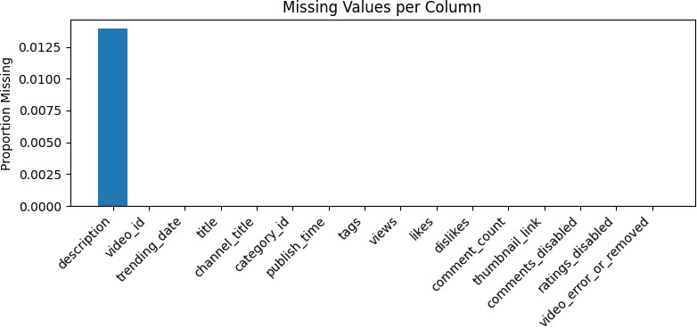

Step 5: Save Raw Data to SQLite Database
Persist the raw DataFrame into a local SQLite database (youtube_trending.db) for SQL-based querying and transformation. Then confirm the data was written by counting the rows.

In [ ]:
# Cell 5: Write raw data to SQLite & verify
engine = create_engine('sqlite:///youtube_trending.db') raw_df.to_sql('raw_data', con=engine, if_exists='replace', index=False) conn = sqlite3.connect('youtube_trending.db')

# use SQL script to find total rows in raw data
cnt = pd.read_sql_query("SELECT COUNT(*) AS cnt FROM raw_data", conn).iloc[0 print("Rows in raw_data table:", cnt)

Rows in raw_data table: 40949

Pipeline 2 - Data Preprocessing

Step 6: Clean Data with SQL Filtering
Create a cleaned version of the dataset by filtering out videos that:

Have 0 views
Were removed or had errors Had comments disabled
Then compare row counts before and after cleaning to verify the impact.

In [ ]:
# Cell 6: Data cleaning via SQL
c = conn.cursor()

c.execute("DROP TABLE IF EXISTS cleaned_data")

# 1) Create cleaned_data table with data from raw_data that have views > 0,
c.execute("""
CREATE TABLE cleaned_data AS SELECT *
FROM raw_data WHERE views > 0
AND video_error_or_removed = 0 AND comments_disabled = 0
""")
conn.commit()

# 2) Compare total rows of data before and after cleaning
before = pd.read_sql_query("SELECT COUNT(*) AS cnt FROM raw_data", conn).ilo after = pd.read_sql_query("SELECT COUNT(*) AS cnt FROM cleaned_data", conn) print(f"Before cleaning: {before} rows\nAfter cleaning: {after} rows")
Before cleaning: 40949 rows After cleaning: 40293 rows

In [ ]:
# 3) Quick overview of cleaned_data (YouTube version)
cleaned_df = pd.read_sql_query("""
SELECT views, likes, dislikes, comment_count FROM cleaned_data
LIMIT 100
""", conn)
print("Sample of cleaned_data:") display(cleaned_df)

# 4) Numeric summary of key columns
stats = pd.read_sql_query(""" SELECT
AVG(views) AS avg_views,
AVG(likes) AS avg_likes, AVG(dislikes) AS avg_dislikes, AVG(comment_count) AS avg_comments, MIN(views) AS min_views,
MAX(views) AS max_views FROM cleaned_data
""", conn)
print("Numeric summary of cleaned_data:") display(stats)

Sample of cleaned_data:

 | views | likes | dislikes | comment_count
0 | 748374 | 57527 | 2966 | 15954
1 | 2418783 | 97185 | 6146 | 12703
2 | 3191434 | 146033 | 5339 | 8181
3 | 343168 | 10172 | 666 | 2146
4 | 2095731 | 132235 | 1989 | 17518
... | ... | ... | ... | ...
95 | 836544 | 40195 | 373 | 976
96 | 284666 | 16396 | 81 | 949
97 | 3371669 | 202676 | 3394 | 20086
98 | 195685 | 14338 | 171 | 1070
99 | 1098897 | 43875 | 1326 | 4702

100 rows × 4 columns

Numeric summary of cleaned_data:

avg_views avg_likes avg_dislikes avg_comments min_views max_vie

0 2.358705e+06 75111.07778 3728.823493 8582.859554 549 2252119

Step 7: Compare Views Distribution Before & After Cleaning
Plot histograms of video view counts before and after data cleaning. This helps assess how the filtering affected the overall distribution and whether extreme or invalid values were removed.

In [ ]:
# Cell 7: Views distribution before vs after cleaning (simple histograms)

# 1) Load the 'views' column from the raw and cleaned datasets
before_v = pd.read_sql_query("SELECT views FROM raw_data", conn)['views'] after_v = pd.read_sql_query("SELECT views FROM cleaned_data", conn)['views'

# 2) Plot histograms to compare the distribution of views before and after c
plt.figure(figsize=(8,4))
plt.hist(before_v, bins=30, alpha=0.5, label='Before', range=(0, 1e7)) plt.hist(after_v, bins=30, alpha=0.5, label='After', range=(0, 1e7)) plt.xlabel("Views")
plt.ylabel("Count")
plt.title("Views Distribution: Before vs After Cleaning") plt.legend()
plt.tight_layout() plt.show()

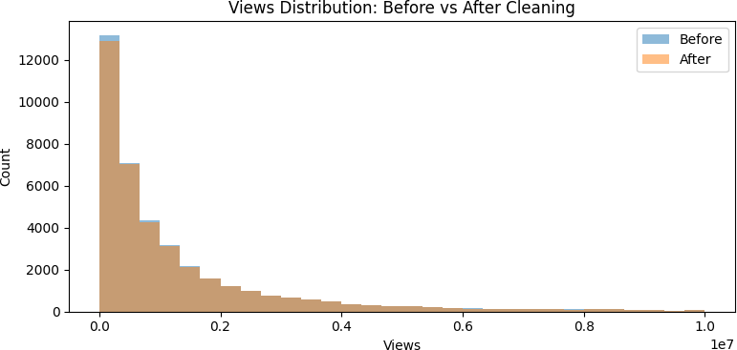

Pipeline 3 - Data Exploration

Step 8: Weekly Trending Video Counts
Use SQL and pandas to parse and convert trending dates. Aggregate video counts per week and plot the number of trending videos over time to uncover seasonality or platform behavior trends.

In [ ]:
# Cell 8: Weekly trending video counts (fixed date parsing, simple line plot

# 1) Query daily trending video counts with corrected date format
monthly = pd.read_sql_query(""" SELECT
date(
'20' || substr(trending_date,1,2) || '-' || substr(trending_date,7,2) || '-' || substr(trending_date,4,2)
) AS TrendDate, COUNT(*) AS Count
FROM cleaned_data GROUP BY TrendDate ORDER BY TrendDate
""", conn)

# 2) Ensure TrendDate is a proper datetime type
monthly['TrendDate'] = pd.to_datetime(monthly['TrendDate'], format='%Y-%m-%d

# 3) Resample counts by week, summing daily counts
weekly_counts = monthly.set_index('TrendDate')['Count'] \
.resample('W') \
.sum()

# 4) Plot weekly trending video counts with a simple line plot

plt.figure(figsize=(10,4))
plt.plot(weekly_counts.index, weekly_counts.values, marker='o') plt.xlabel("Week")
plt.ylabel("Number of Trending Videos") plt.title("Weekly Trending Video Counts") plt.tight_layout()
plt.show()

# 5) Display the monthly daily counts dataframe
display(monthly)
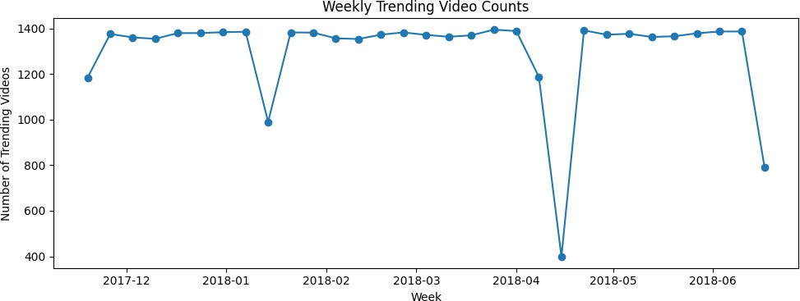

 | TrendDate | Count
0 | 2017-11-14 | 198
1 | 2017-11-15 | 198
2 | 2017-11-16 | 197
3 | 2017-11-17 | 197
4 | 2017-11-18 | 197
... | ... | ...
200 | 2018-06-10 | 198
201 | 2018-06-11 | 198
202 | 2018-06-12 | 198
203 | 2018-06-13 | 197
204 | 2018-06-14 | 198

205 rows × 2 columns

Pipeline 4 - Feature Engineering

Step 9: Engagement & Popularity

Add basic new features:

Engagement: Combined count of views, likes, and comments
TitleLength: Character count of the video title
is_popular: A binary label marking videos with above-median views as “popular”
Also plot distributions of these new features and visualize the class balance of popularity.

In [ ]:
# Cell 9: Feature Engineering – Basic numeric & title length #
# 1) Compute median views from cleaned_data
median_views = pd.read_sql_query("SELECT views FROM cleaned_data", conn)['vi

# 2) Calculate and create new features: total engagement (sum of views + lik
c.execute("DROP TABLE IF EXISTS feat_basic") c.execute(f"""
CREATE TABLE feat_basic AS SELECT *,
(views + likes + comment_count) AS Engagement, LENGTH(title) AS TitleLength,
CASE WHEN views > {median_views:.0f} THEN 1 ELSE 0 END AS is_popu FROM cleaned_data

""")
conn.commit()

# 3) Load new features from database
fb = pd.read_sql_query("SELECT Engagement, TitleLength, is_popular FROM feat

# 4) Plot Engagement distribution plt.figure(figsize=(6,3)) plt.hist(fb['Engagement'], bins=30) plt.title("Engagement Distribution") plt.xlabel("Engagement") plt.ylabel("Count") plt.tight_layout()
plt.show()

# 5) Plot Title Length distribution plt.figure(figsize=(6,3)) plt.hist(fb['TitleLength'], bins=30) plt.title("Video Title Length Distribution") plt.xlabel("Title Length (chars)") plt.ylabel("Count")
plt.tight_layout() plt.show()

# 6) Plot Popular vs Unpopular count
plt.figure(figsize=(4,3))
counts = fb['is_popular'].value_counts().sort_index() plt.bar(['Unpopular','Popular'], counts.values) plt.title("Popularity Class Balance") plt.ylabel("Count")

plt.tight_layout() plt.show()

# 7) Display the feature table
display(fb)
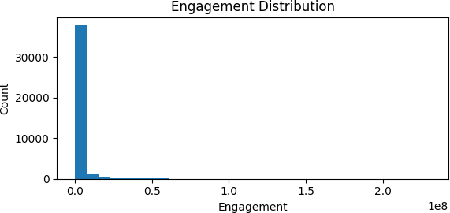
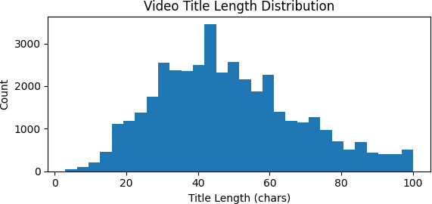

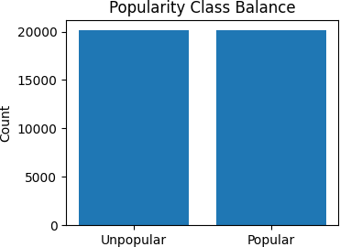

 | Engagement | TitleLength | is_popular
0 | 821855 | 34 | 1
1 | 2528671 | 62 | 1
2 | 3345648 | 53 | 1
3 | 355486 | 32 | 0
4 | 2245484 | 24 | 1
... | ... | ... | ...
40288 | 1726426 | 28 | 1
40289 | 1128742 | 26 | 1
40290 | 1118511 | 84 | 1
40291 | 5866858 | 35 | 1
40292 | 10807993 | 64 | 1

40293 rows × 3 columns

Step 10: Ratio-Based Metrics
Add two derived metrics:

like_ratio: Likes per view
comment_ratio: Comments per view

These ratios normalize engagement by view count. Histograms show their distributions, giving insight into relative engagement.

In [ ]:
# Cell 10: Feature Engineering – Derived ratios #

# 1) Create ratio features: like-to-view and comment-to-view ratios from bas
c.execute("DROP TABLE IF EXISTS feat_ratios") c.execute("""
CREATE TABLE feat_ratios AS SELECT *,
CAST(likes AS FLOAT)/views AS like_ratio, CAST(comment_count AS FLOAT)/views AS comment_ratio
FROM feat_basic
""")
conn.commit()

# 2) Load the ratio features from the database
fr = pd.read_sql_query("SELECT like_ratio, comment_ratio FROM feat_ratios",

# 3) Plot Like-to-View Ratio distribution as histogram
plt.figure(figsize=(6,3)) plt.hist(fr['like_ratio'], bins=30) plt.title("Like-to-View Ratio") plt.xlabel("Like Ratio") plt.ylabel("Count") plt.tight_layout()
plt.show()

# 4) Plot Comment-to-View Ratio distribution as histogram
plt.figure(figsize=(6,3)) plt.hist(fr['comment_ratio'], bins=30) plt.title("Comment-to-View Ratio") plt.xlabel("Comment Ratio") plt.ylabel("Count")
plt.tight_layout() plt.show()

# 5) Display the ratio features table
display(fr)
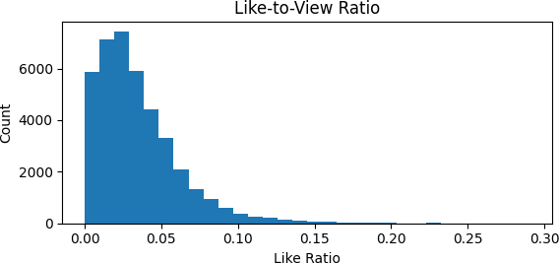

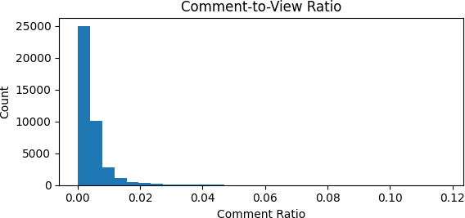

 | like_ratio | comment_ratio
0 | 0.076869 | 0.021318
1 | 0.040179 | 0.005252
2 | 0.045758 | 0.002563
3 | 0.029641 | 0.006253
4 | 0.063097 | 0.008359
... | ... | ...
40288 | 0.022639 | 0.001576
40289 | 0.056356 | 0.003696
40290 | 0.045073 | 0.003743
40291 | 0.034086 | 0.002312
40292 | 0.034647 | 0.014049

40293 rows × 2 columns

In [ ]:
# New Cell: Histogram of the new ratio features
# Load sample (10000 rows) of ratio features for analysis and visualization
ratios_df = pd.read_sql_query(""" SELECT like_ratio, comment_ratio
FROM feat_ratios LIMIT 10000
""", conn)

# Plot histogram of like-to-view ratio (values clipped at 0.1 for better vis
plt.figure(figsize=(10,3)) plt.subplot(1,2,1)
plt.hist(ratios_df['like_ratio'].clip(upper=0.1), bins=30) plt.title("Like-to-View Ratio (clipped at 0.1)") plt.xlabel("like_ratio")
plt.ylabel("Count")

# Plot histogram of comment-to-view ratio (values clipped at 0.01 for better
plt.subplot(1,2,2) plt.hist(ratios_df['comment_ratio'].clip(upper=0.01), bins=30) plt.title("Comment-to-View Ratio (clipped at 0.01)") plt.xlabel("comment_ratio")
plt.tight_layout() plt.show()

# Show the SQL table so far
display(ratios_df)
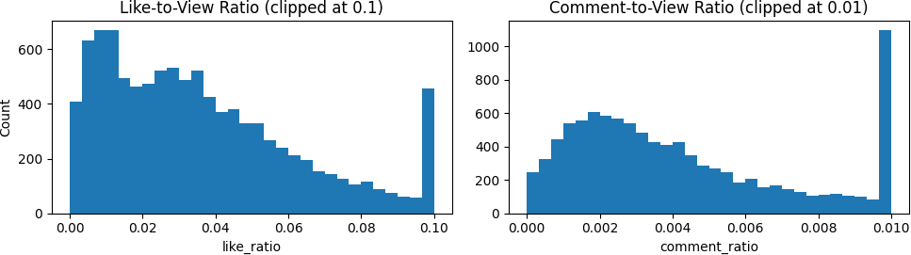

 | like_ratio | comment_ratio
0 | 0.076869 | 0.021318
1 | 0.040179 | 0.005252
2 | 0.045758 | 0.002563
3 | 0.029641 | 0.006253
4 | 0.063097 | 0.008359
... | ... | ...
9995 | 0.011471 | 0.000595
9996 | 0.030624 | 0.001034
9997 | 0.006333 | 0.001079
9998 | 0.010888 | 0.001472
9999 | 0.013744 | 0.004686

10000 rows × 2 columns

Step 11: Temporal Attributes
Extract:

publish_hour: Hour of video publishing
publish_dayofweek: Day of the week (0 = Sunday)

Plot these features to understand when videos are commonly uploaded.

In [ ]:
# Cell 11: Feature Engineering – Temporal features #

# 1) Extract publish hour and publish day of week from publish_time, creatin
c.execute("DROP TABLE IF EXISTS feat_temp") c.execute("""
CREATE TABLE feat_temp AS SELECT f.*,
CAST(strftime('%H', publish_time) AS INTEGER) AS publish_hour, CAST(strftime('%w', publish_time) AS INTEGER) AS publish_dayofwee
FROM feat_ratios f
""")
conn.commit()

# 2) Load the new temporal features from the database
ft = pd.read_sql_query("SELECT publish_hour, publish_dayofweek FROM feat_tem

# 3) Plot Publish Hour distribution as histogram plt.figure(figsize=(6,3)) plt.hist(ft['publish_hour'], bins=24, range=(0,23)) plt.title("Distribution of Publish Hour") plt.xlabel("Hour of Day")
plt.ylabel("Count") plt.tight_layout() plt.show()

# 4) Plot Publish Day of Week distribution as histogram plt.figure(figsize=(6,3)) plt.hist(ft['publish_dayofweek'], bins=7, range=(0,6)) plt.title("Distribution of Publish Day") plt.xlabel("Day of Week (0=Sun)")
plt.ylabel("Count") plt.tight_layout() plt.show()

# 5) Display the extracted temporal features table
display(ft)

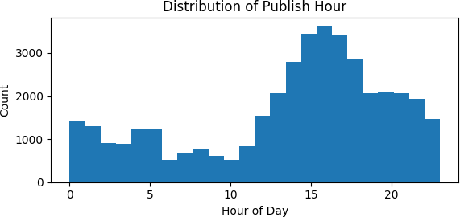
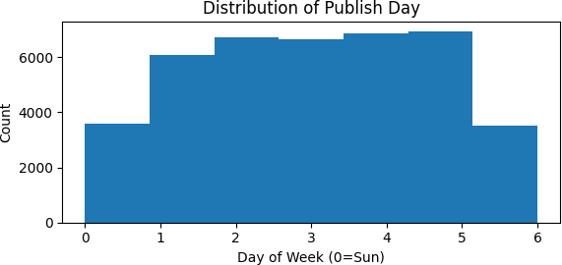

 | publish_hour | publish_dayofweek
0 | 17 | 1
1 | 7 | 1
2 | 19 | 0
3 | 11 | 1
4 | 18 | 0
... | ... | ...
40288 | 13 | 5
40289 | 1 | 5
40290 | 17 | 5
40291 | 17 | 4
40292 | 17 | 4

40293 rows × 2 columns

Step 12: Channel-Level Aggregates
Aggregate features at the channel level:

Number of videos Total views
Average likes

Then merge these channel-level metrics back into the main dataset. Finally, show correlations between all numeric features using a heatmap to check for redundancy or predictive power.

In [ ]:
# Cell 12: Feature Engineering – Channel aggregates & correlation #

# 1) Aggregate channel-level stats: count of videos, total views, and averag
c.execute("DROP TABLE IF EXISTS channel_agg") c.execute("""
CREATE TABLE channel_agg AS SELECT channel_title,
COUNT(*) AS num_videos, SUM(views) AS total_views, AVG(likes) AS avg_likes
FROM feat_temp GROUP BY channel_title
""")
conn.commit()

# 2) Combine channel-level aggregates with detailed features by joining on c

c.execute("DROP TABLE IF EXISTS features_final") c.execute("""
CREATE TABLE features_final AS
SELECT t.*, c.num_videos, c.total_views, c.avg_likes FROM feat_temp t
LEFT JOIN channel_agg c USING(channel_title) """)
conn.commit()

# 3) Load selected features from final table and compute their correlation m ff = pd.read_sql_query("SELECT num_videos, total_views, avg_likes FROM featu corr = ff.corr()

# 4) Plot Correlation Matrix with Heatmap
plt.figure(figsize=(5,4))
plt.imshow(corr, cmap='viridis', aspect='auto') plt.colorbar(label='Correlation')
plt.xticks(range(len(corr)), corr.columns, rotation=45, ha='right') plt.yticks(range(len(corr)), corr.columns)
plt.title("Channel-Level Feature Correlations") plt.tight_layout()
plt.show()

# 5) Show the SQL table so far
display(ff)
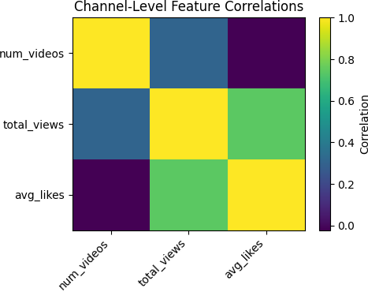

 | num_videos | total_views | avg_likes
0 | 95 | 232745266 | 108499.389474
1 | 24 | 97556377 | 116435.375000
2 | 74 | 240999117 | 175268.621622
3 | 147 | 142231380 | 20405.380952
4 | 89 | 590616191 | 330282.831461
... | ... | ... | ...
40288 | 65 | 57641422 | 24093.476923
40289 | 50 | 53189544 | 72969.140000
40290 | 36 | 28093537 | 35714.750000
40291 | 3 | 16880390 | 192520.666667
40292 | 41 | 315404711 | 281794.975610

40293 rows × 3 columns

Pipeline 5 - Model Selection

Step 13: Prepare Data for Engagement Prediction & Visual EDA
Define a new binary prediction task: classify videos into high vs low engagement (based on median Engagement ).

In [ ]:
# Cell 13: Prepare Data for Engagement‐Level Prediction & Extended EDA #
# 1) Load our engineered feature table
df_feat = pd.read_sql_query("SELECT * FROM features_final", conn)

# 2) Compute median Engagement (views + likes + comments) median_eng = df_feat['Engagement'].median() print(f"Median Engagement: {median_eng:.0f}")

# 3) Define binary target: high engagement if above median
df_feat['high_engagement'] = (df_feat['Engagement'] > median_eng).astype(int

# 4) Select input features (omit raw counts to avoid leakage)
features = [
'TitleLength','like_ratio','comment_ratio', 'publish_hour','publish_dayofweek', 'num_videos','total_views','avg_likes'
]
X = df_feat[features]

y = df_feat['high_engagement']

# 5) Train/test split (stratify to keep class balance)
X_train, X_test, y_train, y_test = train_test_split( X, y, test_size=0.2, random_state=42, stratify=y
)
print("Train shape:", X_train.shape, "Test shape:", X_test.shape)
# --- Extended Visualizations --- # A) Class balance in training set
plt.figure(figsize=(4,3))
counts = y_train.value_counts().sort_index() plt.bar(['Low','High'], counts.values, color=['skyblue','salmon']) plt.title("Training Set: Low vs High Engagement") plt.ylabel("Number of Videos")
plt.tight_layout() plt.show()

# B) Title length distribution by engagement class plt.figure(figsize=(6,3)) plt.hist(df_feat.loc[df_feat.high_engagement==0, 'TitleLength'],
bins=30, alpha=0.5, label='Low Engagement') plt.hist(df_feat.loc[df_feat.high_engagement==1, 'TitleLength'],
bins=30, alpha=0.5, label='High Engagement') plt.xlabel("Title Length (chars)") plt.ylabel("Count")
plt.title("Title Length by Engagement Class") plt.legend()
plt.tight_layout() plt.show()

# C) Like-to-view ratio by engagement class plt.figure(figsize=(6,3)) plt.hist(df_feat.loc[df_feat.high_engagement==0, 'like_ratio'],
bins=30, alpha=0.5, label='Low Engagement') plt.hist(df_feat.loc[df_feat.high_engagement==1, 'like_ratio'],
bins=30, alpha=0.5, label='High Engagement') plt.xlabel("Like-to-View Ratio")
plt.ylabel("Count")
plt.title("Like Ratio by Engagement Class") plt.legend()
plt.tight_layout() plt.show()

# D) Comment-to-view ratio by engagement class plt.figure(figsize=(6,3)) plt.hist(df_feat.loc[df_feat.high_engagement==0, 'comment_ratio'],
bins=30, alpha=0.5, label='Low Engagement') plt.hist(df_feat.loc[df_feat.high_engagement==1, 'comment_ratio'],
bins=30, alpha=0.5, label='High Engagement') plt.xlabel("Comment-to-View Ratio") plt.ylabel("Count")
plt.title("Comment Ratio by Engagement Class") plt.legend()

plt.tight_layout() plt.show()
Median Engagement: 706995
Train shape: (32234, 8) Test shape: (8059, 8)
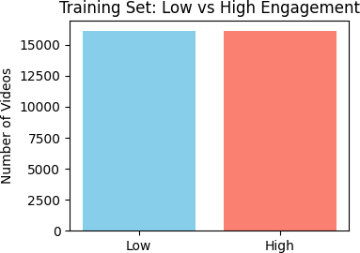
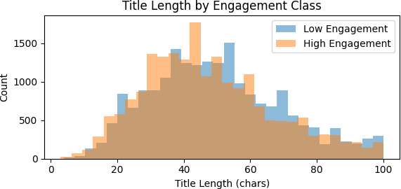

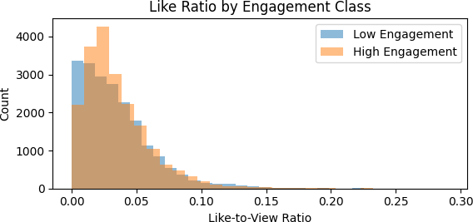
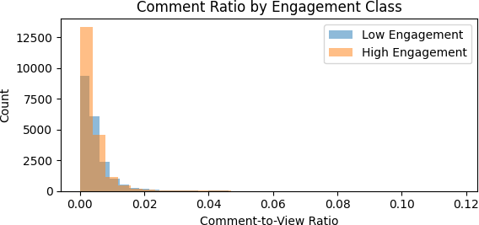

Pipeline 6 - Hyperparameter Tuning & Pipeline 7 - Model Training

Step 14: Train & Tune Models Quickly Using GridSearchCV
Train three ensemble classifiers (Random Forest, Gradient Boosting, AdaBoost) with small grids and fewer CV folds for speed. Store best models and their test accuracies.

In [ ]:
# Cell 14: Faster Hyperparameter Tuning & Evaluation #
# To cut training time, we:

# - Reduce CV folds from 5 → 3
# - Narrow each model’s grid to one or two settings
# - Keep n_jobs=-1 so each search still uses all cores efficiently

from sklearn.ensemble import RandomForestClassifier, GradientBoostingClassif
from sklearn.model_selection import GridSearchCV
from sklearn.metrics import accuracy_score

# 1) Define our ensemble models
models = {
'RandomForest': RandomForestClassifier(random_state=42), 'GradientBoosting':GradientBoostingClassifier(random_state=42), 'AdaBoost': AdaBoostClassifier(random_state=42)
}

# 2) Slimmed-down grids for quick tuning
param_grid = { 'RandomForest': {
'n_estimators': [100], # single setting
'max_depth': [None, 10]
},
'GradientBoosting': { 'n_estimators': [100],
'learning_rate': [0.1] # single setting
},
'AdaBoost': {
'n_estimators': [50], # single setting
'learning_rate': [1.0]
}
}

tuned_acc = {} tuned_models = {}

# 3) Run 3-fold CV for each model
for name, model in models.items(): print(f"Tuning {name} (fast)…") gs = GridSearchCV(
estimator=model, param_grid=param_grid[name], cv=3, # fewer folds scoring='accuracy',
n_jobs=-1
)
gs.fit(X_train, y_train) # much faster grid search
best = gs.best_estimator_ tuned_models[name] = best

# 4) Evaluate on test set
preds = best.predict(X_test)
tuned_acc[name] = accuracy_score(y_test, preds)
print(f"→ {name} best params: {gs.best_params_}, test accuracy: {tuned_a

Tuning RandomForest (fast)…
→ RandomForest best params: {'max_depth': None, 'n_estimators': 100}, test a ccuracy: 0.9666
Tuning GradientBoosting (fast)…
→ GradientBoosting best params: {'learning_rate': 0.1, 'n_estimators': 100}, test accuracy: 0.8623
Tuning AdaBoost (fast)…
→ AdaBoost best params: {'learning_rate': 1.0, 'n_estimators': 50}, test acc uracy: 0.8383

Pipeline 7 - Model Evaluation

Step 15: Visualize Model Accuracies
Plot a simple bar chart comparing the tuned test accuracies of the three models. This helps choose the best-performing classifier for dashboard deployment.

In [ ]:
# Cell 15: Plot Tuned Model Accuracies
names = list(tuned_acc.keys()) # List of model names from tune accuracies = [tuned_acc[n] for n in names] # Corresponding accuracy values x = np.arange(len(names)) # Array of indices for plotting

# Plot Accuracy of each Tuned Model with Bar Chart
plt.figure(figsize=(6,4)) plt.bar(x, accuracies)
plt.xticks(x, names, rotation=45, ha='right') plt.ylim(0,1)
plt.ylabel("Accuracy")
plt.title("Tuned Ensemble Model Accuracies for Engagement") plt.tight_layout()
plt.show()

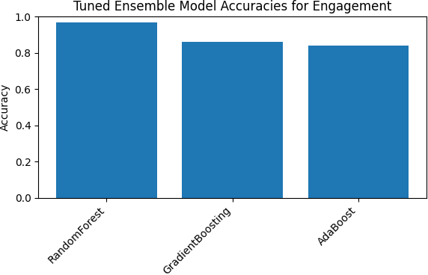

Pipeline 8 - Model Deployment

Step 16: Gradio Dashboard – Insights & Model Outputs
Create an interactive dashboard using Gradio. It shows:

- Title length distribution by engagement class
- Tuned model accuracies
- Top 10 channels by predicted engagement (using Random Forest)
- Feature importance chart from Random Forest
The dashboard makes it easy to explore the modeling results and insights visually.

In [ ]:
# Cell 16: Gradio Dashboard — Title Length EDA & Extended Top Channels
def show_dashboard():
# 1) Title length distribution by engagement class
fig1, ax1 = plt.subplots(figsize=(6,3)) ax1.hist(df_feat.loc[df_feat.high_engagement==0, 'TitleLength'],
bins=30, alpha=0.5, label='Low Engagement') ax1.hist(df_feat.loc[df_feat.high_engagement==1, 'TitleLength'],
bins=30, alpha=0.5, label='High Engagement') ax1.set_xlabel("Title Length (chars)") ax1.set_ylabel("Count")
ax1.set_title("Title Length by Engagement Class") ax1.legend()

fig1.tight_layout()

# 2) Tuned model accuracies
fig2, ax2 = plt.subplots(figsize=(6,3)) names_list = list(tuned_acc.keys())
accs = [tuned_acc[n] for n in names_list] x = np.arange(len(names_list))
ax2.bar(x, accs, color='lightgreen') ax2.set_xticks(x)
ax2.set_xticklabels(names_list, rotation=45, ha='right') ax2.set_ylim(0,1)
ax2.set_ylabel("Accuracy") ax2.set_title("Tuned Model Accuracies") fig2.tight_layout()

# 3) Top-10 channels by average predicted engagement using the best Rand
best_model = tuned_models['RandomForest'] probs = best_model.predict_proba(X_test)[:,1]
video_meta = df_feat.loc[X_test.index, ['channel_title']].copy() video_meta['pred_high_eng'] = probs
channel_probs = video_meta.groupby('channel_title')['pred_high_eng'].mea top10_channels = (
channel_probs
.sort_values(ascending=False)
.head(10)
.reset_index()
.rename(columns={'pred_high_eng': 'avg_pred_high_eng'})
)

# 4) Feature importances of the RandomForest
importances = best_model.feature_importances_
imp_df = pd.Series(importances, index=features).sort_values() fig4, ax4 = plt.subplots(figsize=(6,3)) imp_df.plot.barh(ax=ax4)
ax4.set_title("RandomForest Feature Importances") fig4.tight_layout()

# Return: title-length hist, accuracies bar, top10 DataFrame, importance
return fig1, fig2, top10_channels, fig4

gr.Interface(
fn=show_dashboard, inputs=[], outputs=[
gr.Plot(label="Title Length by Engagement Class"), gr.Plot(label="Tuned Model Accuracies"), gr.Dataframe(label="Top 10 Channels by Predicted Engagement"), gr.Plot(label="Feature Importances")
],
title="US YouTube Video Engagement Dashboard & Model Insights", description="Title length EDA, tuned model performance, top channels, an
).launch()

Setting queue=True in a Colab notebook requires sharing enabled. Setting `sh are=True` (you can turn this off by setting `share=False` in `launch()` expl icitly).

Colab notebook detected. To show errors in colab notebook, set debug=True in launch()
Running on public URL: https://817a6f93cbdcf32aa9.gradio.live

This share link expires in 72 hours. For free permanent hosting and GPU upgr ades, run `gradio deploy` from Terminal to deploy to Spaces (https://hugging face.co/spaces)

No interface is running right now

Out[ ]:

This notebook was converted with convert.ploomber.io

